OLYMPICS OF THE VISUAL ARTS REGISTRATION FORM
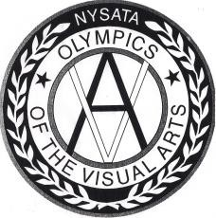
This Registration Form is to be completed in advance and turned in at the Check-In Table when you arrive at the OVA competition.

SCHOOL DISTRICT: CONTACT PERSON: SCHOOL ADDRESS: CITY: STATE: ZIP:
CATEGORY | LEVEL | INDIV SCHOOL NAME | NO. OF STUDENTS
DRAWING | ELEM
 | MIDDLE
 | HIGH
PAINTING | ELEM
 | MIDDLE
 | HIGH
ARCHITECTURE | ELEM
 | MIDDLE
 | HIGH
FASHION DESIGN | ELEM
 | MIDDLE
 | HIGH
ILLUSTRATION | ELEM
 | MIDDLE
 | HIGH
SCULPTURE | ELEM
 | MIDDLE
 | HIGH
PHOTOGRAPHY | ELEM
 | MIDDLE
 | HIGH
JEWELRY DESIGN | ELEM
 | MIDDLE
 | HIGH

TOTAL NUMBER OF STUDENTS REPRESENTED: TOTAL TEAM ENTRIES: ELEMENTARY MIDDLE HIGH SCHOOL

OVERALL TOTAL NUMBER OF ENTRIES:

ANY SPECIAL ACCOMODATIONS REQUESTED? Please DESCRIBE YOUR SPECIAL NEEDS:

